Updating Contact Information

Interactive Table of Contents

Introduction – What are Contacts? – Updating Your Contact Information – Conclusion

Introduction
Hello; my name is Megan Jones and I am an Instructional Designer here at EKU. Today, as part of our faculty professional development, we are going to cover updating your contact information using the Contact tool in Blackboard. As you know, Blackboard has particular quirks and alternative ways of performing tasks, so hopefully you will find this short tutorial helpful.

What are Contacts?
Blackboard uses a tool called Contacts to manage contact information for instructors and facilitators in online or hybrid/blended courses.

Why use Contacts?
While it is possible to create your own contact information by editing a course item, Blackboard can simplify that process by providing a pre-determined format to display your contact information. Contact can then be linked in the Course Menu for easy access. Adding course menu links is covered in another tutorial.

Updating Your Contact Information
Updating your contact information within a course is a pretty straightforward process. We will begin by logging in to Blackboard and entering a course. From there, let’s take a look at the Contacts tool, which is located in the Course Tools group under the Course Management menu (Figure 1):
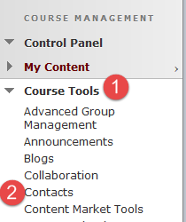
Figure 1: Click Course Tools within the Course Management menu (1), and then click Contacts (2)

After clicking the Contacts tool, you will be taken to the Contacts area. This is where we will create contact information for you. The next step will guide you to click the Create Contact button at the top of the page (Figure 2).
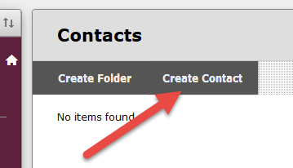 Figure 2: Click the Create Contact button
Once you click on the Create Contact button, you will see a new page appear, called Create Contact. For this example, let’s put in my information (Figure 3):
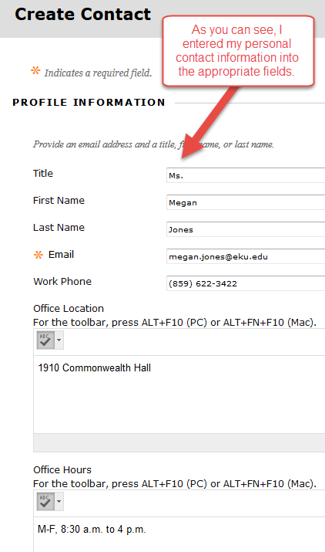
Figure 3: Enter your contact information

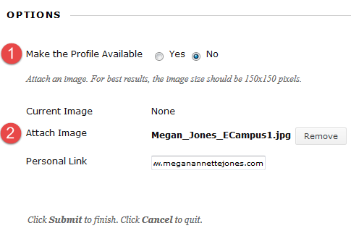
You can also add a picture and make sure the contact information is available for the student to see (Figure 4). Remember, your photo is optimally viewed if it is 150 pixels tall and 150 pixels wide.
Figure 4: Make your profile available to students (1) and attach a photo of yourself (2)

After making your changes and adding a photo, click Submit. Blackboard will allow you to view your changes (Figure 5):
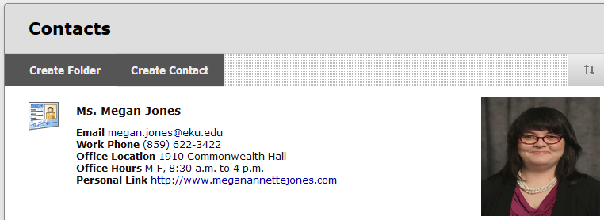 Figure 5: Finished Contacts page

Conclusion
Hopefully, as a result of this handout, you have become familiar with the basics of updating your contact information on Blackboard. If you need help or support, please do not hesitate to contact me. I can be reached at megan.jones@eku.edu and (859) 622-3422. Thank you!

