Importing Blackboard Course Packages

Interactive Table of Contents

Introduction – What is a Course Package? – Why use Course Packages? – First Steps – Importing a Course Package -- Conclusion

Introduction
Hello; my name is Megan Jones and I am an Instructional Designer here at EKU. Today, as part of our faculty professional development, we are going to cover how to import Blackboard course packages. The purpose of importing course packages is to make our lives easier as we develop new courses on Blackboard.

What is a Course Package?
A course package is an exported course ZIP file that can be imported in to other Blackboard courses. This ZIP file contains presets for layouts and content that you can import in to another course without having to re-create layouts or content. You will still need to update course information, such as dates, any updated handouts or course materials, and new textbooks, course readings, and test banks.

Why use Course Packages?
Course Packages are an easy, convenient way to import pre-designed courses and content in to Blackboard. This can be a time-saver for experienced online faculty or a guide for faculty new to teaching online.

First Steps
The first step to importing a course package is downloading a course package to import. The IDC Web site has a pre-created course package file for faculty to use. It is located at this link. Once you visit the site, be sure to click on the “Click Here to Download” text to begin downloading an exported course ZIP file. This is the file we will be importing in to your Blackboard course. The file will download automatically.
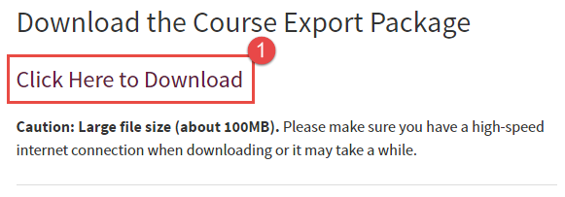
Figure 1: IDC Web site download link
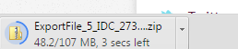
Figure 2: Exported ZIP course file will download automatically

Importing a Course Package

After you have downloaded the exported ZIP course file, navigate to your empty course shell in Blackboard. In this case, I am working with an internal IDC development course shell.
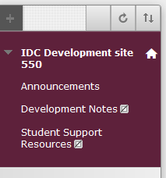
Figure 3: Empty course shell

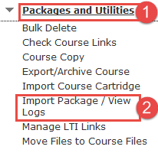
Figure 4: Click Packages and Utilities (1) and then click the Import Package/View Logs link (2)

After you enter your course, scroll down to the Course Management menu and look for the Packages and Utilities option. Click on Packages and Utilities and then click on the Import Package/View Logs link. You should now see the Import Package/View Logs page.
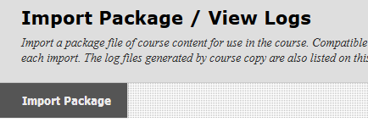
Figure 5: Import Package/View Logs page

Click on the Import Package button. The Import Package page should load and present you with a few options to consider. First, click on the Browse My Computer button and find your downloaded ZIP file from the IDC Web site. Click Open to select your file for upload.
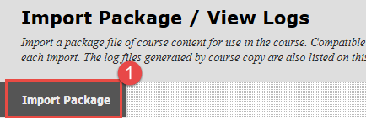
Figure 6: Click on Import Package (1)
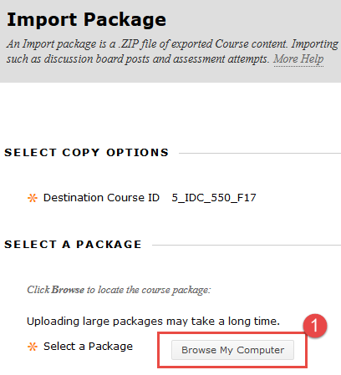
Figure 7: Click the Browse My Computer button (1)
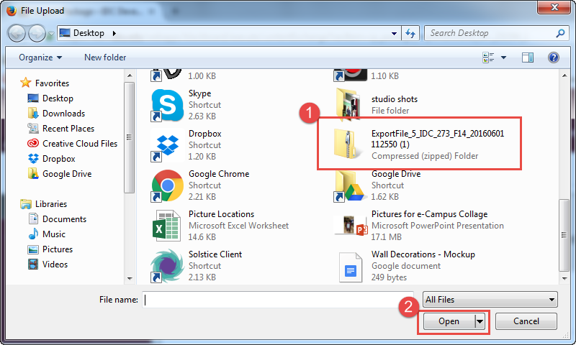
Figure 8: Find and click your file (1), then click Open (2)
After clicking Open, you should be taken back to the Import Package page. Your selected file should appear beside the Selected File text. Next, click the Select All button to make sure you include all pre-created course components. Click Submit to proceed with the ZIP package import.
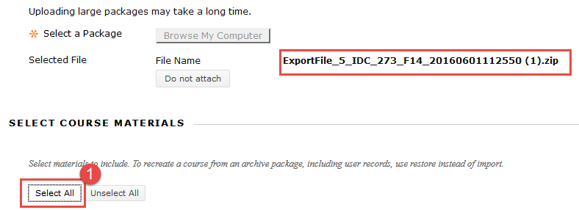
Figure 9: You should see your selected file by the Selected File text. Click Select All to include all pre-created course components (1)
After clicking Submit, you will be taken back to the Import Package/View Logs page. At the top, you should see some notifications letting you know the package was successfully uploaded and is importing.
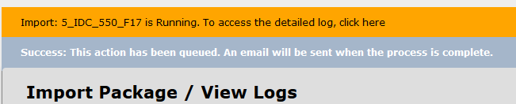
Figure 10: ZIP package upload was successful and is running
After a minute or so, click the Refresh button on your browser or in Blackboard and you should see a log and your updated menu.
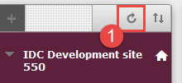 Figure 11: Blackboard refresh button
Figure 12: Blackboard log on ZIP package import
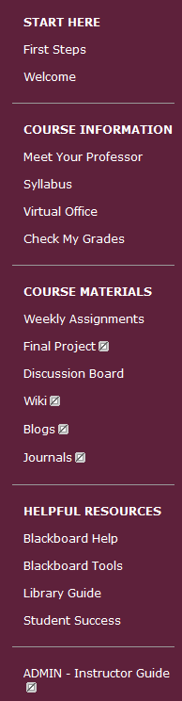
Figure 12: Updated Course Menu
Please keep in mind that this is just a basic framework with pre-created content items. You will need to add your course content to this layout. Also, we have included an ADMIN – Instructor Guide link with helpful handouts, articles, presentations, and tutorials about Blackboard and teaching online. We hope you find these resources helpful!

Conclusion
In this tutorial, we reviewed how to import a Course Package in to Blackboard. I hope you find this process as convenient as I do when working with online courses. If you need help or support, please do not hesitate to contact me. I can be reached at megan.jones@eku.edu and (859) 622-3422. Thank you!

