Embedding Google Docs in Blackboard

Interactive Table of Contents

Introduction – What is Google Docs? – Why use Google Docs? – Creating a Google Document – First Steps – Embedding Your Google Doc -- Conclusion

Introduction
Hello; my name is Megan Jones and I am an Instructional Designer here at EKU. Today, as part of our faculty professional development, we are going to cover how to embed Google Docs in Blackboard. The purpose of embedding is to be able to update the Google Document without having to go back into Blackboard to re-upload or update the file. This saves a ton of time, and hopefully you will find this convenient.

What is Google Docs?
Google Docs is a cloud-based word processing program, available through any browser with an internet connection. You do not have to download or install any program to use Google Docs. All you need is a Google Account. To sign up for a Google Account, please click this link.

Why use Google Docs?
Google Docs is a convenient, portable platform to easily edit and share your files with others. You can also embed your Google Doc into a Web page or LMS (Blackboard and others), which allows you to update the document in Google Docs without having to update the item itself in Blackboard or anywhere else. Obviously, this has the potential of saving a ton of time.

Creating a Google Document
Creating a basic Google Document is addressed in another tutorial.

First Steps
The first step in this process would be to actually create a Google Document with the information you would like to share on Blackboard. In this tutorial, I am going to create a Syllabus in Google Docs.
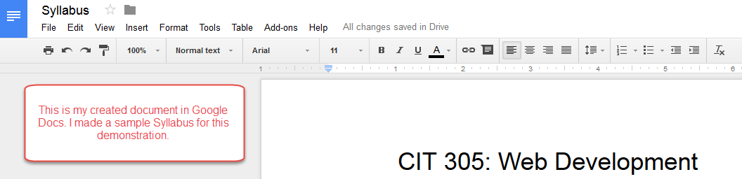
Figure 1: Created Google Document
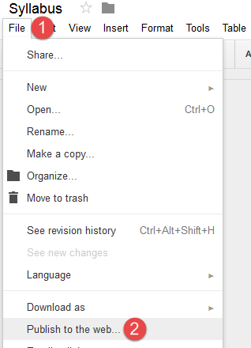
Once you have your document created, there is a setting you MUST enable before being able to embed your Google Document. This setting is located in the File menu, and it is called Publish to the web…

Figure 2: Click File (1) and
then Click Publish to the web… (2)

Click on Publish to the web… and you should see a dialog box pop up. Be sure to click the Embed tab beneath the descriptive text.
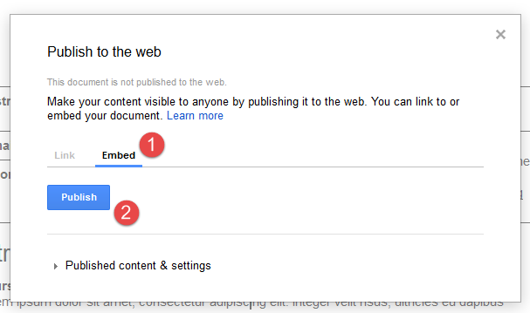
Figure 3: Click Embed (1) and then click Publish (2)

After selecting Embed, click the Publish button. Google will confirm that you want to share the document online by asking, “Are you sure you want to publish this selection?” Click OK.
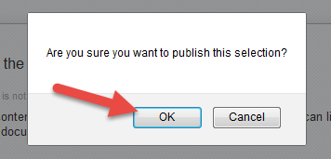 Figure 3: Click OK to confirm Publishing
Once you click OK, Google will process your document and spit out some HTML code. It may look something like this:
<iframe src="https://docs.google.com/document/d/18xygsANRcac8jYjHNeR2DMbwHm5Xwh9AexiZA4KIKWs/pub?embedded=true"></iframe>
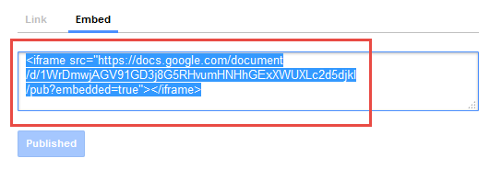
Figure 4: Embed Code
Don’t be intimidated by this as you will be simply copying and pasting this code in to Blackboard. If you’re curious, this code is for embedding what we call an iframe, which is a container for your content.
Copy the Embed code by pressing Ctrl+C on your keyboard or by right-clicking your mouse and selecting Copy from the mouse menu.
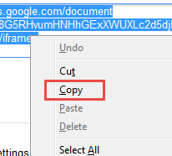 Figure 5: Copy the Embed code from your Google Doc
Now that code is copied to your computer’s Clipboard. Keep in mind that this selection will be overwritten if you copy any other text on your Computer. Let’s go to Blackboard.

Embedding Your Google Doc
Log in to Blackboard and navigate to your course. In this tutorial, I created a Syllabus in Google Docs, so it would be fitting to include that embed code in a Syllabus item. Click on Syllabus, and you should see your content page appear.
If you do not already have an item created within this page, click on Build Content and select Item. If you already have an item created, click on the grey down arrow by the title of the item and select Edit. You should see the Edit Item screen in either case.
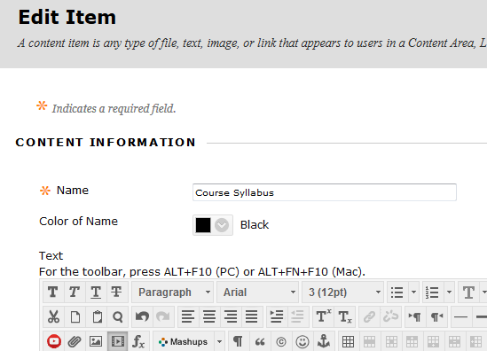
Figure 6: Edit Item page in Blackboard
At this stage, you should see the text editor below the name and color items. Look for the HTML button.
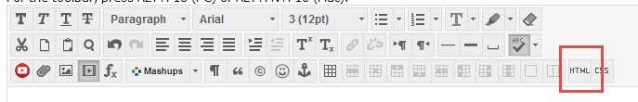
Figure 7: Click the HTML button to bring up the HTML code view window

Click the HTML button, and a HTML code view window should pop up. This window is where you will be pasting the code you copied earlier.
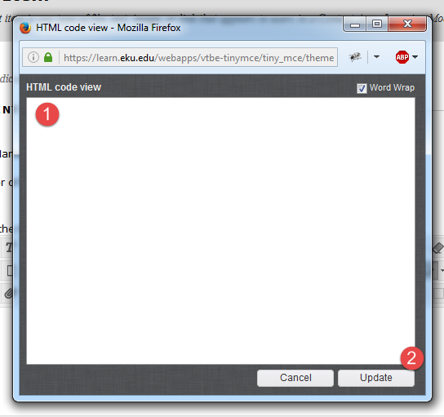
Figure 8: HTML code view window – Paste your Embed code from your Google Doc (1) and then click Update (2)
Click anywhere you would like to embed your Google Document. In this case, since I have no other content on this item, I pasted it at the beginning. Click Update after you have pasted your embed code from your Google Doc.
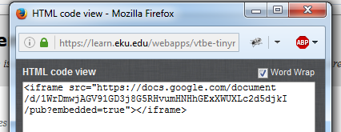
Figure 9: Pasted Embed code

After clicking Update, you should see a small, yellow placeholder in your text editor. This is where your document will appear.
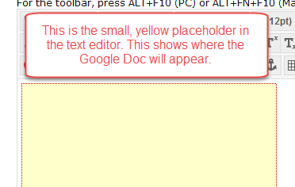 Figure 10: Yellow Placeholder
Don’t click Submit just yet – you may not be happy with the size, and we can quickly change that by making minor edits to the HTML code you pasted earlier.

Editing Your Google Doc Embed Code
If you are not happy with the size of your embed box, which I’m often not, you will need to edit the embed code. To do so, click on the HTML button in your text editor. The HTML code view window should appear. Your initial code should have looked something like this:
<iframe src="https://docs.google.com/document/d/18xygsANRcac8jYjHNeR2DMbwHm5Xwh9AexiZA4KIKWs/pub?embedded=true"></iframe>
After you clicked Update earlier, Blackboard actually did some of the coding for you. It added both width and height to your object automatically.
<p><iframe width="320" height="240" src="https://docs.google.com/document/d/18xygsANRcac8jYjHNeR2DMbwHm5Xwh9AexiZA4KIKWs/pub?embedded=true"></iframe></p>
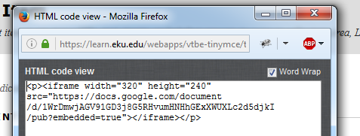
Figure 11: Blackboard coding width and height automatically
All that you need to do now is replace the numbers 320 and 240 with something else. I personally use 800 width and 600 height for embedded Google Docs – they just seem to look better that way:
<p><iframe width="800" height="600" src="https://docs.google.com/document/d/18xygsANRcac8jYjHNeR2DMbwHm5Xwh9AexiZA4KIKWs/pub?embedded=true"></iframe></p>
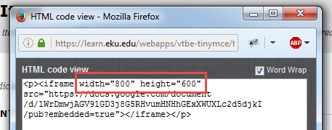
Figure 12: Changing width and height measurements to make it larger
Click Update. You should see the yellow box in your text editor at a larger size. Click Submit to see your results.
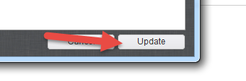
Figure 13: Click the Update button to save any HTML changes
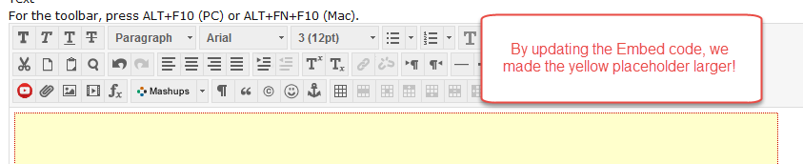
Figure 14: Result of the Embed code edit – the yellow placeholder is larger!

Bingo! Your Google Doc is now embedded in your Blackboard item. The better news is that you can update your Google Doc in your browser and your changes will automatically update here. There is no need to edit the Blackboard item further unless you decide to embed another Google Doc or add a PDF or DOCX file to the item.
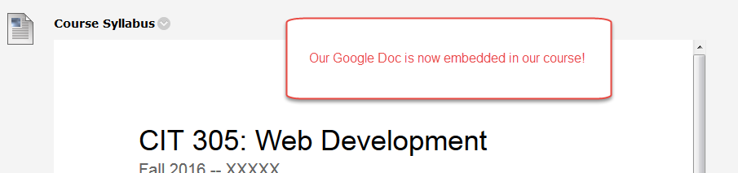
Figure 15: Result of Google Document embed. Our Google Doc is now embedded in the course!

Conclusion
In this tutorial, we reviewed how to embed a Google Doc into Blackboard. I hope you find this process as convenient as I do when working with online courses. If you need help or support, please do not hesitate to contact me. I can be reached at megan.jones@eku.edu and (859) 622-3422. Thank you!

