Availability Dates

Interactive Table of Contents

Introduction – What are Availability Dates? – How Do Availability Dates Work? – When to Use Availability Dates – Availability Dates – Conclusion

Introduction
Hello; my name is Megan Jones and I am an Instructional Designer here at EKU. Today, as part of our faculty professional development, we are going to cover Availability Dates. As you know, Blackboard has particular quirks and alternative ways of performing tasks, so hopefully you will find this short tutorial helpful.

What are Availability Dates?
Availability dates are a way of guiding students through materials on Blackboard by directly changing when content items appear. There are several ways to control how your content appears in Blackboard using adaptive release, but that is beyond the scope of this tutorial. Those ways are:
- Time Release: Controlling when content items appear by using availability dates;
- Membership Release: Certain groups of students can access controlled materials;
- Grade/Completion Release: Students can access items only if they achieve a certain score or complete a prior assignment or quiz.

How Do Availability Dates Work?
Availability dates work by using specific time and date settings to control how students view materials in a course. An example of this would be allowing a quiz to release on a specific date and time.

When to Use Availability Dates
Availability dates can be used in several teaching scenarios. Professors usually have their own style or method of running courses, but I will share my own experiences. When I was a faculty member, I used availability dates in a couple of scenarios:
- Pacing Students through Modules: Sometimes you want the student to follow you through the course and not work ahead.
- Allowing Students to Work Ahead: If students complete certain assignments and quizzes, they can move on to the next module or assignment.
As stated previously, faculty can implement availability dates on items of their choosing – some ways help meet policy requirements, some methods help with convenience, and other releases control student behavior within a course.

Implementing Availability Dates in Blackboard
The premise is simple – we want to control students’ access to materials. We will cover how to change availability dates for items in this tutorial.

Availability Dates
Let’s take a look at a basic quiz in Blackboard (F1):
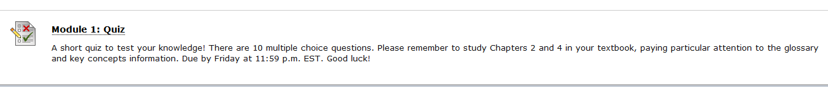
Figure 1: Blackboard Quiz
In order to control when the quiz is released, be sure to look at the Edit the Test Options selection after clicking the down arrow by the title of the quiz (F2). Make sure that Edit Mode is on when you are making changes to your course (F3), otherwise you may not be able to access the Edit the Test Options page.
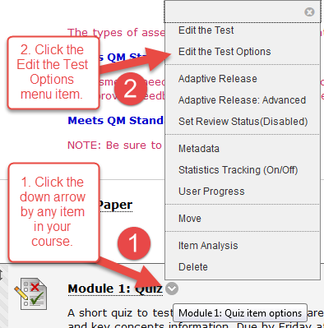
Figure 2: Accessing the Edit the Test Options menu item
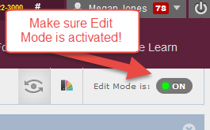
Figure 3: Edit Mode
Once you are in the Edit the Test Options page, you should see the title and description of the quiz (F4):
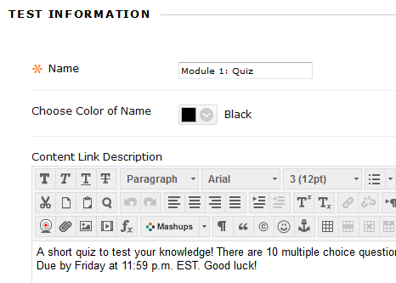
Figure 4: Edit the Test Options page
Scroll down to the Test Availability section (F5), and you should see various options that control access to your quiz, including making the quiz available to students, adding a new announcement to tell students about the test, controlling the number of attempts, and timers/force completion.
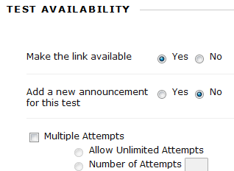
Figure 5: Test Availability Section
After viewing these options, you should see a “Display After” and “Display Until” area (F6). This is where you will set your test availability dates. Students will not be able to access an assessment outside of the times you specify in your quiz. After changing the dates, you can save your changes by clicking Submit.
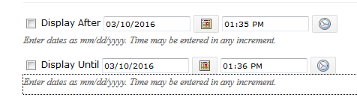
Figure 6: Test Availability Option
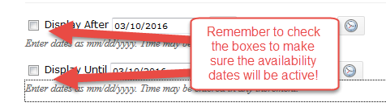
Figure 7: Check the Test Availability Dates
Did You Know?
You can set availability dates on any item in Blackboard; it does not have to be a quiz or assignment.
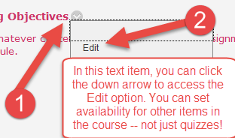

Conclusion
Hopefully, as a result of this handout, you have become familiar with the basics of availability dates. If you need help or support, please do not hesitate to contact me. I can be reached at megan.jones@eku.edu and (859) 622-3422. Thank you!

