Adding Users to a Course

Interactive Table of Contents

Introduction – Types of Users – Adding Users – Conclusion

Introduction
Hello; my name is Megan Jones and I am an Instructional Designer here at EKU. Today, as part of our faculty professional development, we are going to cover adding users to a course in Blackboard. As you know, Blackboard has particular quirks and alternative ways of performing tasks, so hopefully you will find this short tutorial helpful.

Types of Users
Blackboard has several types of users from which to choose. As a faculty, there will be one role that you will probably use most frequently. That is the Student role. Other roles include Instructor, Teaching Assistant, Course Builder, Grader, Guest, Auditor, and Instructional Designer. You will be an Instructor by default in your course. That means you will have complete access to all course resources, save for overall administrative access, which is reserved for very few users.

Adding Users
Adding Users to a course is one of the most important features a faculty can control. To begin, log in to Blackboard and navigate to your course. Look at the Course Management menu (beneath the course menu) and click Users and Groups. The menu should drop down to show two options: Groups and Users (Figure 1). Click on Users.
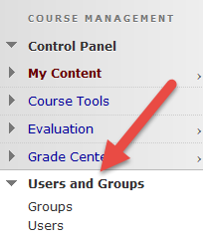
Figure 1: Accessing users via the Course Management menu

Once you have clicked on Users, you will be taken to the Users page. On this page, you are able to view all users enrolled in your course and other information, such as their roles in the course (i.e. student, instructor). From this page, you may search for users or add them. For this exercise, let’s add my student account to this course.
To begin, click the Find Users to Enroll button, located beneath the Users page title (Figure 2):
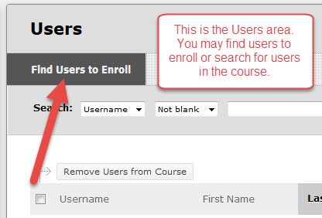
Figure 2: The Users area allows you to add and search for users

After clicking on Find Users to Enroll, you will be taken to the Add Enrollments page. This is where you will find the student’s username and add it to your course (Figure 3). Click the Browse… button to search for users to enroll in your course.
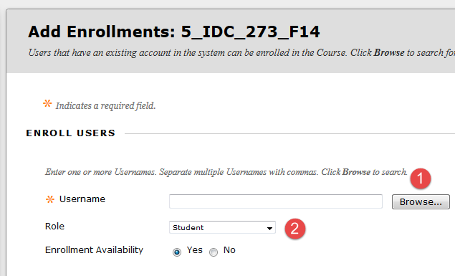
Figure 3: Find the student’s username by clicking Browse... (1) and make sure the Role is set to Student (2). Click Submit to save your changes.

After clicking Browse…, a new window will open. That window will prompt you to search for users. If you know the student’s name or part of their username, you may use the filters and search bar here to locate the proper user account to add. For this exercise, I searched for my student account by typing in jonesm (Figure 4). Click the check boxes by the users you want to add. Remember, you may add multiple users at the same time by checking the corresponding boxes by their names.
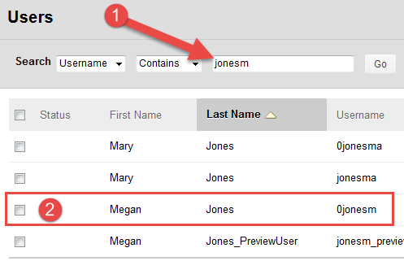
Figure 4: After you click Browse…, a new window will pop up, prompting you to search for a user (1). Click the check box by the user you want to add, and click Submit… (2).

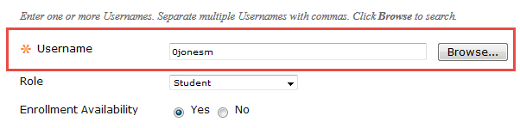
Figure 5: After you click Submit, you should see the user name populate in the Username box. Click Submit to add the user(s) to your course. Please remember to make sure the Student Role is selected.

Figure 6: User successfully added to course

Conclusion
Hopefully, as a result of this handout, you have become familiar with the basics of updating your contact information on Blackboard. If you need help or support, please do not hesitate to contact me. I can be reached at megan.jones@eku.edu and (859) 622-3422. Thank you!

