Adding a File to a Course

Interactive Table of Contents

Introduction – Types of Files – Adding Files – Content Attachments – Ordering Course Items – Text Editor Attachments – Conclusion

Introduction
Hello; my name is Megan Jones and I am an Instructional Designer here at EKU. Today, as part of our faculty professional development, we are going to cover adding files to a course in Blackboard. As you know, Blackboard has particular quirks and alternative ways of performing tasks, so hopefully you will find this short tutorial helpful.

Types of Files
Blackboard supports several file types. A list of them can be found at Blackboard’s library site. For quick reference, here are some common types of files you can upload:
- Microsoft Office files – DOC, DOCX, XLS, PPT
- Image files – JPEG, JPG, GIF, TIFF
- Video files – AVI, MPG, MPEG, MOV
- Text/Document files – PDF, HTML, TXT

Adding Files
Knowing how to add files to a course gives you flexibility as an instructor. There are two places where you can attach files:
- Content attachments: This type of upload creates a separate content item within a Blackboard course page.
- Text editor attachments: This type of upload is used when you are linking to files from within the Blackboard text editor.

Content Attachments
The first step to adding a content attachment is to navigate to where you would like to display your file. For this example, I’m going to add a content attachment to my Module 1 page within Blackboard. I navigated to the Module 1 page and then clicked on the menu item Build Content, which is located below the title (in this case, Module 1)(Figure 1). Select the File link. You can see where you are within the course by viewing the breadcrumb links below the main Blackboard menu (Figure 2).
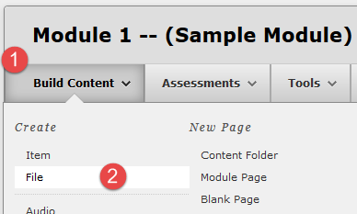Figure 1: Click Build Content (1) and select File (2)
. Figure 2: Breadcrumbs
After you have clicked on File, you should see the Create File page load. There are a few options to consider, so let’s look at the items beneath the Select File heading first. This area is where you will actually upload the file. We have three options when uploading files to Blackboard:
- Browse My Computer: This allows you to select a file from your computer to upload.
- Browse Content Collection: This option allows you to select a file from your Content Collection. Your Content Collection is an area of your course where you can select from previously uploaded files. Some people use Content Collection to store files they will use in the course, so they can then be copied to future courses within Blackboard. Please note: Not all Learning Management Systems will automatically add files within the Content Collection to a reformatted course. Remember to always keep a back-up copy of your files.
- Inserting a Hyperlink within Text: This option is only available in items with text included, which will be covered later in this lesson.
Once you decide which option you want to choose, click the corresponding button (Figure 3):
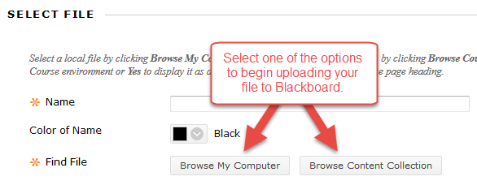
Figure 3: Find file – Browse My Computer or Browse Content Collection
For this example, I am going to upload a local file to Blackboard by choosing Browse My Computer. After selecting this option, you should see a File Upload window pop up. This is where you will choose the file you want to upload (Figure 4):
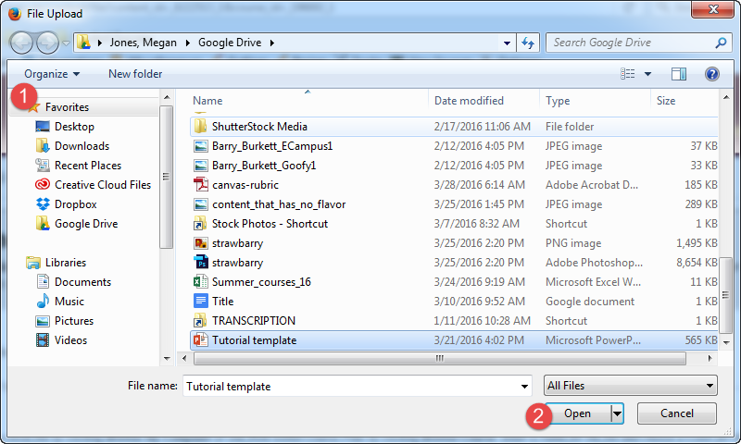
Figure 4: Navigate to your file, click on it to select it, and then click Open
Upon clicking Open, Blackboard will show the file name and type by the Selected File item. At this point, create a name for your file (Figure 5). You may also choose to Select a Different File if you accidentally uploaded the wrong one. We recommend using the color Black for titles since it provides the greatest contrast and visibility to students who are covered by ADA accommodations, including those who may be color-blind.
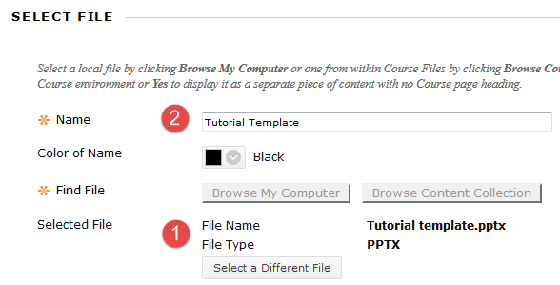
Figure 5: Verify you have the correct file selected (1) and name it appropriately (2)
Next, we will look at the options beneath the File Options and Standard Options sections. Under File Options, you can select the option to have the file open in a new window (which is recommended) or add an alignment, if you are using that Blackboard feature. Under Standard Option, you can control access to the file as well as setting when the item is available to students (Select Date and Time Restrictions) (Figure 6). When you are finished, click Submit.
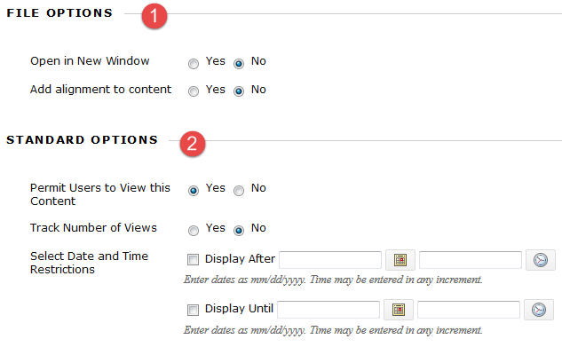
Figure 6: Check the appropriate File Options (1) or Standard Options (2)
After clicking Submit, you will be taken back to the original page (in my case, the Module 1 page). You should see your file as the last option on the page (Figure 7). You may re-order contents by clicking and dragging individual items or using the up/down button to re-arrange items en masse.
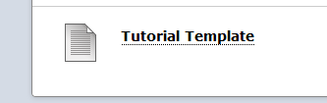
Figure 7: Tutorial Template course item at the bottom of the course page

Rearranging Course Items
There are two ways to re-arrange course items within a Blackboard course page. The first way is to click and drag individual items up and down the page to create the order you want (Figure 8):
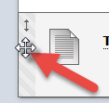
Figure 8: Click and drag the left striped column beside course items to re-order them
The second way to re-order content en masse is to click the up/down button in the upper, right-hand corner of the course page (Figure 9). A small window should pop up, showing all of the content items on that page. Click the item you want to move, and press the up/down buttons to re-order the item. Click Submit to save your changes.
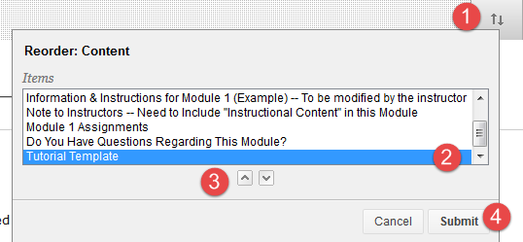
Figure 9: Click the up/down button (1) and then select the item you want to move (2). Click the up/down buttons (3) to move the item to your desired location on the page. Click Submit (4) to save your changes.

Text Editor Attachments
The next way to add attachments to your course involves the text editor screen. This will allow you to add a text description or more information to an attached file, instead of just placing the file itself without an explanation. To begin, find the location where you would like to upload your file. In this case, I’ll use the Module 1 page again (Figure 10). Click Build Content and then click Item.
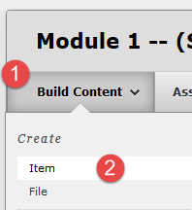
Figure 10: Click Build Content (1) and then Click Item (2)

Once you click Item, a new page called Create Item should load. There are three sections you must customize: Content Information, Attachments, and Standard Options. Enter a custom title and description of the file you are going to upload (Figure 11). You may also include instructions on what to do with the file as well. You can also upload multiple files.

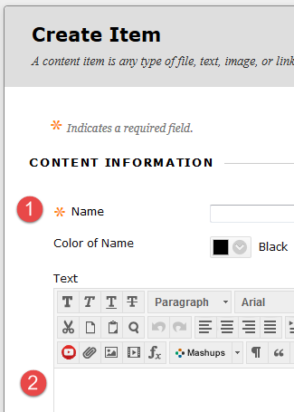
Figure 11: Create a custom title (1) and description of the item (2)
The next step is to take a look at the Attachments section and upload a file. It is the same process we used when we uploaded a file as a Content Attachment.
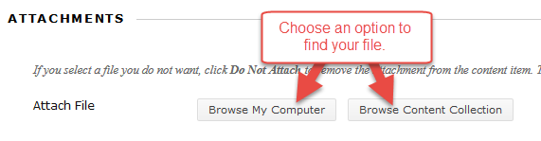
Figure 12: Choose a method of uploading
As before, I will click the Browse My Computer button to upload a local file on my computer (Figure 4):

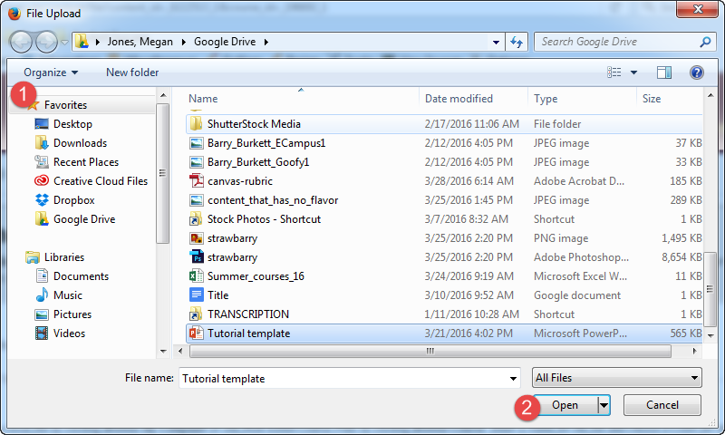
Figure 4: Navigate to your file, click on it to select it, and then click Open
After clicking Open, you should see the file and its title on the Create Item page (Figure 12). If you uploaded the incorrect file, you can click Do not attach to remove the file.
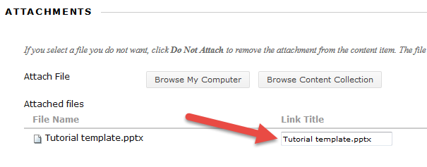
Figure 12: Verify you have the right file attached, and customize the link’s title if desired
Next, set up the options in the Standard Options area, which is exactly the same format as before (Figure 13). You can permit users to view the item, track the number of views, or set availability dates for the item. Click Submit after you are finished editing your options.
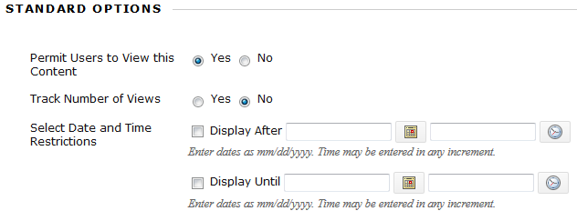 Figure 13: Standard Options
After clicking Submit, you should see the item at the bottom of the course page (Figure 14). You may re-order the items as you wish by clicking and dragging or re-ordering them using the up/down button.
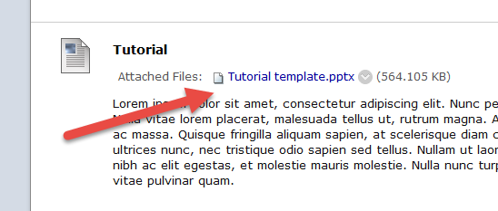
Figure 14: Content item with attachment and text

Inserting a Hyperlink
The third method of inserting files to your course is called hyperlinking. To create a hyperlink to a file, there are a few steps. Remember, you can add a hyperlink within any text editor in Blackboard.
Let’s create a simple hyperlink that navigates the student to the Google search engine. Of course, if you have a different file or Web page you’d like to link to, you’ll need to go through the same steps to obtain the Uniform Resource Locator (URL). The first step is to open a Web browser and navigate to the Web page or document you would like to link.
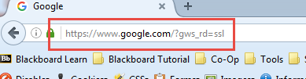
Figure 15: The URL is located in the address bar of your Web browser (red box). Copy the hyperlink by highlighting it with your mouse, right click, and select Copy. Alternatively, you may also use the key combination CTRL and C to copy the text.
The next step is to create an item in Blackboard, as we did earlier with this tutorial. Type in a custom title and text (Figure 16).

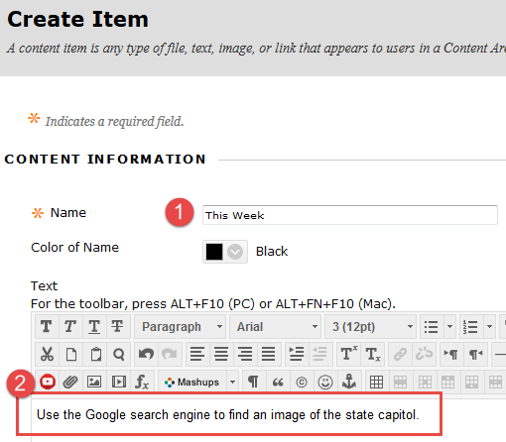
Figure 16: After clicking Create Item, customize your title (1) and text description (2)
Highlight the text you want to link with your mouse and click the hyperlink button in the Blackboard text editor (Figure 17):
Figure 17: Highlight the text you want to link (1), and click the hyperlink button (2).

After you click the hyperlink button, a new window will pop up. It will ask for the Link Path and Target. The Link Path box is where you will paste the URL you obtained earlier from your browser’s address bar. Make sure the Target drop-down menu has Open in New Window selected, or students will be navigated to a security page before accessing the linked resource. Click the Insert button to save your changes.
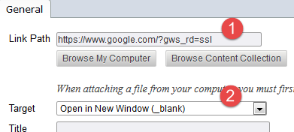
Figure 18: Paste the URL you copied from your browser’s address bar in to the Link Path box (1), and make sure to select Open in New Window (2) from the Target drop-down menu. Click Insert to finish.

Once you click Insert, you should see the text you selected earlier highlighted in blue. That text is now a hyperlink that navigates to http://www.google.com. When a student clicks on the hyperlink, they will be instantly taken to the Web site. Click Submit to save your changes.
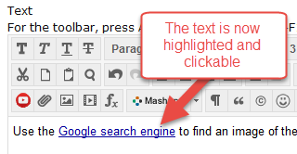
Figure 19: Clickable hyperlinked text

Conclusion
Hopefully, as a result of this handout, you have become familiar with the basics of uploading files in Blackboard. If you need help or support, please do not hesitate to contact me. I can be reached at megan.jones@eku.edu and (859) 622-3422. Thank you!

