Adding a Course Menu Item

Interactive Table of Contents

Introduction – What are Course Menu Items? – Creating Course Menu Items – Adding a Content Area – Adding a Tool Link – Adding a Course Link – Conclusion

Introduction
Hello; my name is Megan Jones and I am an Instructional Designer here at EKU. Today, as part of our faculty professional development, we are going to cover how to add menu items to your Blackboard course. Adding menu items is arguably one of the most important aspects of designing a quality course.

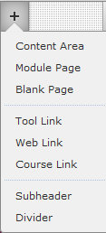
What are Course Menu Items?
Figure 1: Course Menu Items

Course menu items are menu links that point to specific areas of the course. They can also link to Blackboard tools, such as groups and discussion boards, and perform the same action as a hyperlink by taking the user to a Web page external to Blackboard. Menu items are versatile in nature and can be customized. On the right, you will see a quick screen capture of the items you can add to your course menu (Figure 1):
Let’s break down these options in detail:
- Content Area: This option will create a custom link in the course menu that points to a blank page. You can add separate items, such as assignments.
- Module Page: This option creates custom link in the course menu that points to Figure 1:
a blank module page. On this page, only certain pre-determined modules can Course
be placed on the page. Menu Items
- Blank Page: This option creates a custom link in the course menu that points to
a customizable page. This page cannot contain course items, such as assignments, folders, etc. However, you can hyperlink any item in the course within the text. Please consult an Instructional Designer before changing any source code (HTML).
- Tool Link: The Tool Link menu item can directly link to any Blackboard tools, including Blogs, Calendar, Wiki, etc. Figure 2 provides a good example:
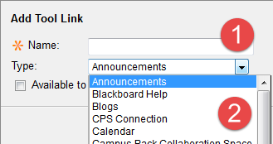
Figure 2: Tool Link; editing the name (1) and type (2)
- Web Link: This course item functions as a hyperlink. You can use this link to take students to an external Web page.
- Course Link: A Course Link item can point students to virtually any location in the course, including tools, assignments, folders, etc. See Figure 3 below for an example of the items you can include in a Course Link:
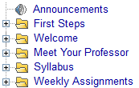
Figure 3: Course Link options
- Subheader: It is useful to classify links in the course by using subheaders. For example, a suitable course subheader could be “Course Information.” Below the subheader, you can include course items that point to a Syllabus link (Figure 4). Remember, subheaders are not interactive – meaning that you cannot click on them.
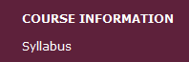
Figure 4: Subheader above Syllabus course link in course menu
- Divider: This option allows you to insert a divider line in between course links and subheaders (Figure 5):
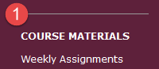
Figure 5: Divider shown above Course Materials subheader (1)

Creating Course Menu Items
In this tutorial, I will show you how to create three course menu items – the “big three”:
- Content Area
- Tool Link
- Course Link
Each one of these course items functions differently in terms of designing a menu for your course. Let’s break down the big three and explain how to implement them.

Adding a Content Area
The first step is logging in to Blackboard and entering your course. Once you are in your course, please take a look at the left menu carefully. You should see a plus () button in the top left corner of the menu. Click this button to see the options to add a course menu item and click Content Area (Figure 6):
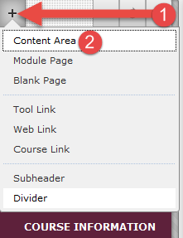
Figure 6: Access course menu items by clicking the plus (1) and selecting Content Area (2)
After clicking on Content Area, a small window will pop up. This window will ask for some basic information from you – in this case, the name of your Content Area is needed. Let’s type in Syllabus (Figure 7):
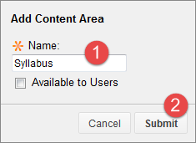
Figure 7: Enter the Content Area name (1) and click Submit (2)
You should see the Syllabus Content Area link at the bottom of the menu. It is placed there automatically by Blackboard. You can re-order the items by clicking and dragging them to their appropriate positions (Figure 8):
Figure 8: Look for the top/down arrows beside any course menu item when you hover over it with your mouse (red circle)
Alternatively, you can also organize your menu en masse by clicking the up/down arrows button () at the top of the left menu (Figure 9):
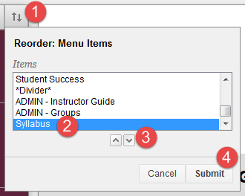
Figure 9: Click the up/down arrows (1) and select the item you want to move (2). Use the arrows at the bottom (3) to move the selected item up and down the menu. Click Submit (4) to confirm your changes.

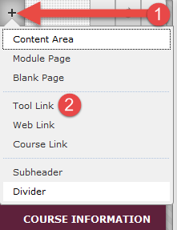

Adding a Tool Link
The first step is logging in to Blackboard and entering your course. Once you are in your course, please take a look at the left menu carefully. You should see a plus () button in the top left corner of the menu. Click this button to see the options to add a course menu item and click Tool Link (Figure 10):

Figure 10:
Click on the plus button (1)
and click Tool Link (2)

For this example, let’s create a custom tool link for a Discussion Board (Figure 11). After clicking the plus button and selecting the Tool Link option (1), the Add Tool Link window will appear. Type “Discussion Board” in the Name box (2) and choose Discussion Board from the drop-down menu (3). Click Submit when you are finished (4), and a Discussion Board course menu item should be at the bottom of your course menu. You can click and drag to reorder, or use the top/down menu to move course menu items to their proper locations (Figure 8, 9).
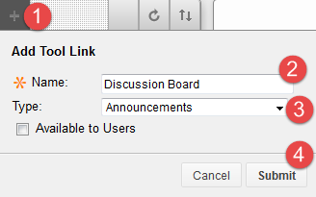
Figure 11: Click the plus button (1), type in a suitable title (2), select the tool you want to link to (3), and click Submit to save your changes

Adding a Course Link
The first step is logging in to Blackboard and entering your course. Once you are in your course, please take a look at the left menu carefully. You should see a plus () button in the top left corner of the menu. Click this button to see the options to add a course menu item and click Course Link (Figure 12):
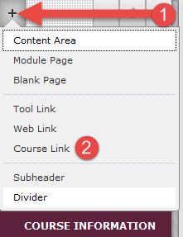 Figure 12: Click the plus button (1) and then click Course Link (2)
After clicking on Course Link, a small window will pop up. This window will ask for some basic information from you – in this case, the options have changed a bit. For this example, we will create a Course Link to take us directly to Module 1 (Figure 13). Under Location, click Browse (2). You will see another window pop up that features all of the items in your course (Figure 14):
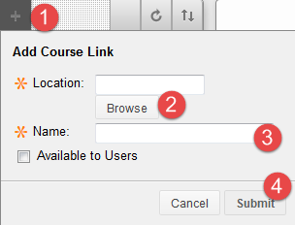
Figure 13: Click the plus button (1) and choose Course Link. Click Browse to find a specific item in your course that you want to link to (2). Then, create a custom name for the link in the Name area (3). Save your changes by clicking Submit (4).

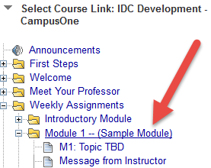
Figure 14: Select the appropriate course item to link.
In this case, I am choosing Module 1.

After clicking on Module 1, or any other item for that matter, and Blackboard will automatically populate the Location and Name entries (Figure 15):
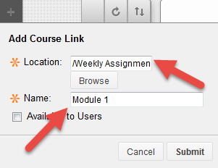
Figure 15: After selecting a course item, Blackboard will populate the Location and Name areas of the window. Click Submit to save your changes.

Once you click Submit, a Course Link for Module 1 will be placed at the bottom of the course menu. You may reorder the menu items as you see fit. If we click on the Module 1 Course Link, it will take us directly to the Module 1 page (Figure 16):
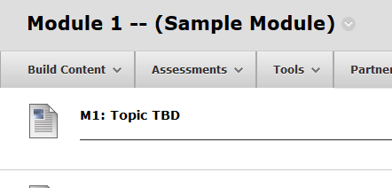
Figure 16: Module 1 link on course menu and the result – Blackboard takes us to Module 1 after clicking on the link.

Congratulations! You have now created a Course Link!

Conclusion
Hopefully, as a result of this handout, you have become familiar with converting your Microsoft Word documents into PDFs. If you need help or support, please do not hesitate to contact me. I can be reached at megan.jones@eku.edu and (859) 622-3422. Thank you!

