Editing Files Using Google Docs

A Modular Alternative to Word’s Copy and Paste

Interactive Table of Contents

Introduction – Why We Avoid Microsoft Word – Google Docs Basics – Creating a New Document – Editing Your Document – Toolbar Breakdown –

Copying Content into Blackboard

Introduction
Hello; my name is Megan Jones and I am an Instructional Designer here at EKU. Today, as part of our faculty professional development, we are going to cover how to edit text files and content. As you know, Blackboard has particular quirks and alternative ways of performing tasks, so hopefully you will find this short tutorial helpful.

Why We Avoid Microsoft Word
The main reason we recommend avoiding using Word documents relates to the copy and paste nature of Blackboard. Many of us, or actually I would say the majority of us, use alternative word processing programs to assemble our content and then use the copy and paste feature to post our content in Blackboard. What’s the problem with using Word to copy and paste course content?
The main problem we encounter is the automatic formatting Blackboard does to any input. Whether it be a table, or a bullet list with text – or even images – Blackboard will reformat the content to its own specifications. To assist with this issue, Blackboard has actually included a button in its text editor that allows us to clear the formatting from any input. The caveat with clearing all formatting? Sometimes we don’t want our format to be altered. And it’s even worse – and time consuming – to go back and reformat input in Blackboard’s text editor.
Fortunately, we have found a versatile solution. That solution comes in the form of cloud-based office programs implemented by Google. We often think of Google as just a search engine, but in reality, Google has several services that I have found useful as an Instructional Designer and former faculty. Today, we will be covering a browser-based program called Google Docs.

Google Docs Basics
Google Docs is a browser-based word processing program. There is no software to install or purchase – you only need to create a Google account. You may notice other programs from Google, including spreadsheet, presentation, and database programs. Google also has cloud storage – similar to Microsoft’s OneDrive – called Google Drive. All of these programs are accessible through a Google account.
For the purpose of this tutorial, we will only be editing a Google Docs file. I will also show you how to input Google Docs content into Blackboard. It may seem complicated at first, but in fact, you may find this method can increase your productivity time – by eliminating the need of reformatting text after pasting the content into Blackboard.
An added benefit of using Google Docs is the embed feature, which allows you to update content automatically in Blackboard, without the need to go back and copy/paste content multiple times. The embed feature is also compatible with other Learning Management Systems – which means that you won’t have to do much to change content if we stop using Blackboard. The embed feature is more advanced, and it would be best to consult an Instructional Designer before altering any source code in Blackboard content items.

Creating a New Document
The first step of creating a new document in Google Docs is opening your Web browser and navigating to https://docs.google.com – you can hold CTRL and click the link with your right mouse button to open the site in a browser. After you have navigated to the site, Google will prompt you for your username and password. This is the step where you would either create an account or log in with your previously created account.
After you log in, you will be brought to the Start a New Document screen.
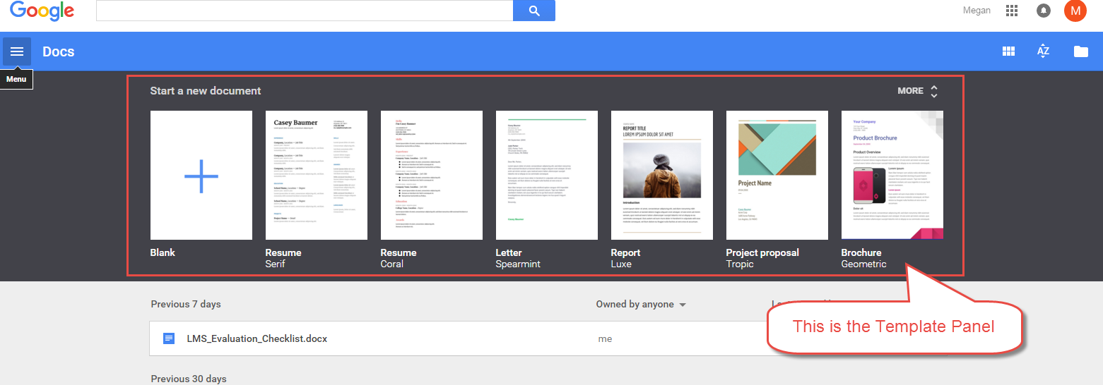
Figure 1: Start a New Document – Template Panel
This screen offers a variety of templates, as well as the option of creating a blank document. Google also shows the most recent documents you have accessed below the template panel.
For this exercise, let’s click on the Blank starter file:
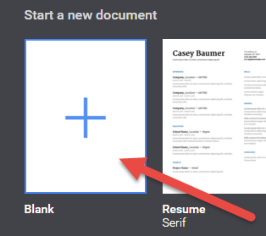Figure 2: Blank File Selection
Once you have clicked on the Blank starter file, Google will bring up a blank document for you within the Web browser. Remember, since this is cloud-based, any and all information entered is immediately saved to Google’s server. Even if the browser crashes, your last changes are preserved.
Figure 3: Blank Document in Google Docs
Congratulations! You have created a new document in Google Docs!

Editing Your Document
As you look at the new blank document, hopefully you’ll notice some features that are very similar to Microsoft Word:
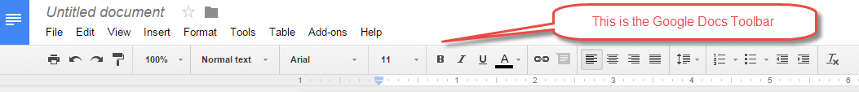
Figure 4: Google Docs Toolbar
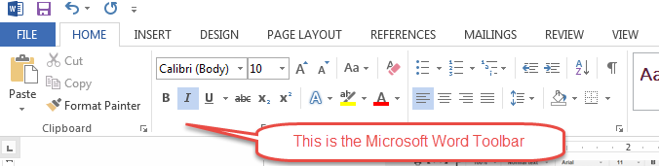
Figure 5: Microsoft Word Toolbar

Toolbar Breakdown
It’s important to get familiar with the Google Docs toolbar. Let’s cover a few of the tools!
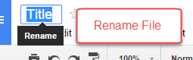
Figure 6: Rename your file by clicking “Untitled Document”
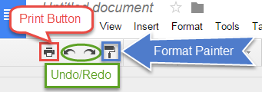
Figure 7: Print, Undo/Redo, Format Painter
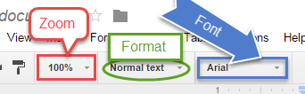
Figure 8: Zoom, Format, Font Tools
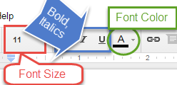
Figure 9: Font Size, Bold/Italics/Underline, Font Color
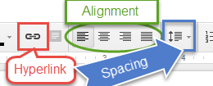
Figure 10: Hyperlink, Alignment, Line Spacing
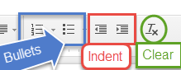
Figure 11: Bullets, Decrease/Increase Indent, Clear Formatting
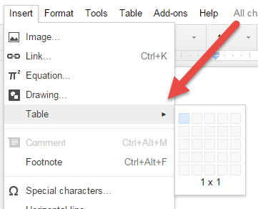
Figure 12: Create a Table by Clicking Insert and Hovering Over Table

Copying Content into Blackboard
Now the moment we have all been expecting – copying content from Google Docs into Blackboard’s text editor.
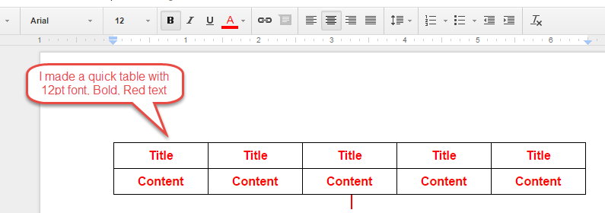
Figure 13: Table with Formatting in Google Docs
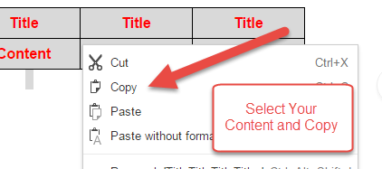
Figure 14: Copy from Google Docs
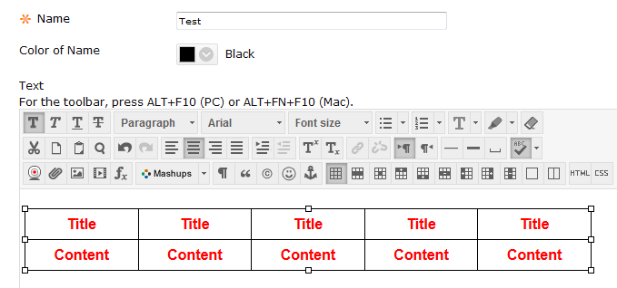
Figure 15: Pasted Table in Blackboard
As you can see, the content that was pasted from Google Docs into Blackboard looks exactly the same. The formatting was preserved using this method.

Conclusion
Hopefully, as a result of this handout, you have become familiar with the basic tools of Google Docs. If you need help or support, please do not hesitate to contact me. I can be reached at megan.jones@eku.edu and (859) 622-3422. Thank you!

