Creating PDF Files Using Microsoft Word

Interactive Table of Contents

Introduction – Why PDFs? – Getting Started with Microsoft Word – Creating a New Document – Converting Your Document

Introduction
Hello; my name is Megan Jones and I am an Instructional Designer here at EKU. Today, as part of our faculty professional development, we are going to cover converting a Microsoft Word document into a PDF. This process is much easier than ever before thanks to updates made to the program.

Why PDFs?
PDF, or Portable Document Format, documents are arguably the most accessible way to view a document online. There are many reasons why PDFs are the preferred document of choice for course developers:
- Mobile Accessibility: Statistically, now more than ever, students use mobile technology to perform routine tasks online. PDFs are very easy to access on a mobile device, and the programs or applications used to view PDFs are often free. While this may not directly affect what we’re addressing in this tutorial, it is a fair point to mention.
- No Downloads and Faster Access: Students do not have to download the file to view it; it is displayed in the browser or within Blackboard, depending on the institution. Additionally, PDF files are generally smaller in size and faster to access for that reason.
- Course Quality: When students download a Word document, it can be edited by the student. While restrictions can be placed in documents, it is easier to produce a PDF that CANNOT be edited by the student. As such, using a PDF instead of a Word file can preserve the integrity of your course.
- Format Preservation: Whatever formatting you used in your document will be preserved in the PDF file.

Getting Started with Microsoft Word
The very first step is to open Microsoft Word. We have two options at this point. We can:
- Open a document;
- Create a new document
For this tutorial, let’s convert a new document into a PDF. Open Microsoft Word by searching for it through the Windows start menu (Figure 1):
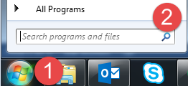
  - Figure 1: Click the Start Menu button (1) and
  - then search by typing “Word” in the search box (2)

Creating a New Document
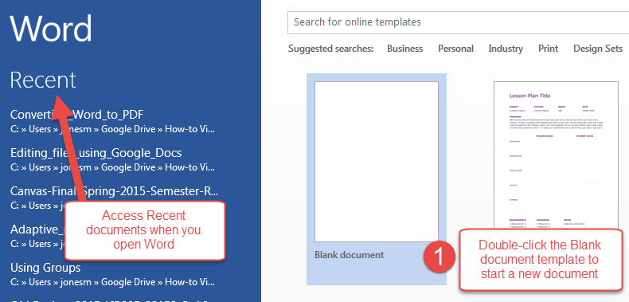
Figure 2: Start a New Document by double-clicking Blank document (1)
This screen offers a variety of templates, as well as the option of creating a blank document. Word also shows the most recent documents you have accessed. You can search for more templates online through Office.com by using the search bar at the top of the screen.
Let’s click on the Blank document and open it in Word (Figure 3):
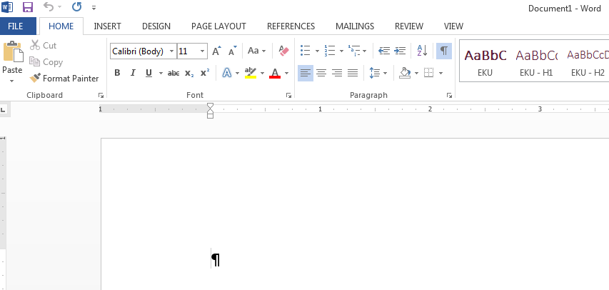
Figure 3: Blank document in Microsoft Word
Once you have clicked on the Blank document template, Word will bring up a blank document for you. Rarely, Word will crash, but there is the option of recovering your file when you restart the program. Let’s make a minor edit to the document by adding some text and formatting (Figure 4):
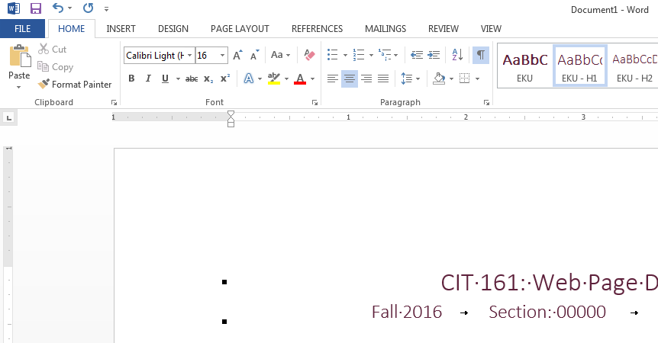
Figure 4: Edited document in Word
Congratulations! You have created and edited a new document in Word!

Converting Your Document
The next obvious step is to actually convert your Word document into a PDF. Luckily, Microsoft built in a feature that allows us to do just that! Let’s click on the File tab, or “backstage” view, and look at the options (Figures 5, 6):
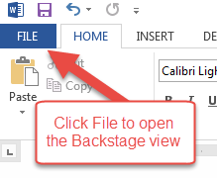
Figure 5: File tab and backstage view options
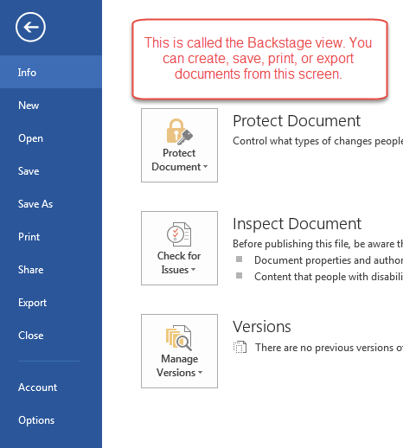
Figure 6: Microsoft Word’s Backstage view
Once we’re in the Backstage view of Microsoft Word, we can find the option to convert our document into a PDF. While you may be looking for a “Convert” button, Microsoft actually placed it in the Export option instead of providing a dedicated menu option (Figure 7):
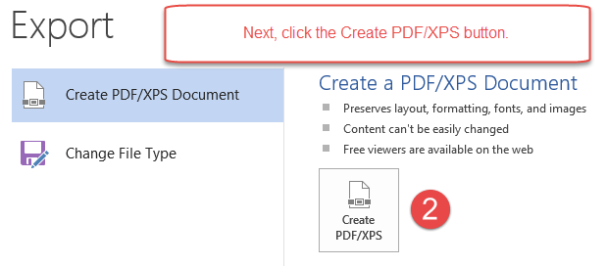
Figure 7: Click on the Export option (1) and then click the Create PDF/XPS button (2)
Now we’re ready to actually convert the document!
After you press the Create PDF/XPS button, a Publish as PDF or XPS window will pop up (Figure 8):
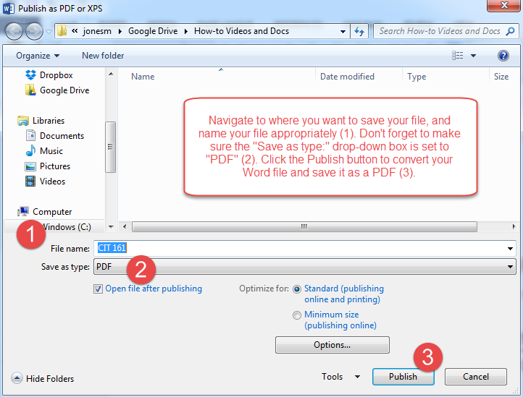
Figure 8: Select your save location and name your file (1) and make sure the Save as type drop-down menu is set to PDF (2). Finally, click Publish to convert your document (3).
You can verify that the document processed correctly by opening the file or checking the save location in the Windows File Explorer (Figure 9):
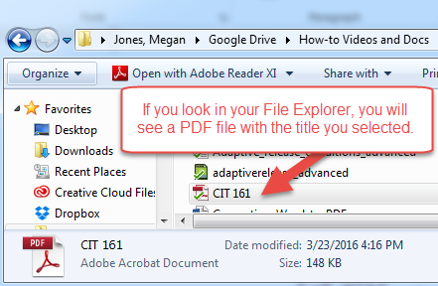
Figure 9: The CIT 161 PDF file I converted is located in my How-to Videos and Docs folder
You should now have a PDF file you can upload to the Blackboard LMS. Congratulations!

Conclusion
Hopefully, as a result of this handout, you have become familiar with converting your Microsoft Word documents into PDFs. If you need help or support, please do not hesitate to contact me. I can be reached at megan.jones@eku.edu and (859) 622-3422. Thank you!

